Build Packs:
Add this inside configuration
<plugin>
<groupId>org.springframework.boot</groupId>
<artifactId>spring-boot-maven-plugin</artifactId>
<configuration>
<!--to build image use this command in same directory as pom.xml "mvn spring-boot:build-image"-->
<image>
<name>talhaatif/${project.artifactId}:s4</name>
</image>
</configuration>
</plugin>

Use this command to build image
mvn spring-boot:build-image

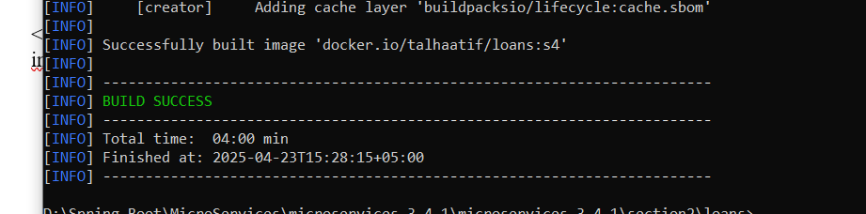

To run
docker run -d -p 8090:8090 talhaatif573/loans:s4

